|  |  |
| --- | --- |
| **Business Process:** | **Business Technology Office - SUNTAX** |
| **Tax Type:** | **All** |
| **Activity:** | **Understanding ECO Team Leads** |
| **Sub-Activity:** | **ZICM_WORKLIST** |

**Purpose/Objective**

GTA’s new Education and Compliance Outreach (ECO) program will be managed and reported from Integrated Compliance Management (ICM). ECO leads will be created and managed using ZICM_WORKLIST. This job aid provides the steps to access an ECO lead and explains the ECO lead screen.

**Steps**

**Accessing the Lead**

ECO Caseworkers will access the lead information using transaction ZICM_WORKLIST.

Enter ZICM_WORKLIST in the Command field.

Click .

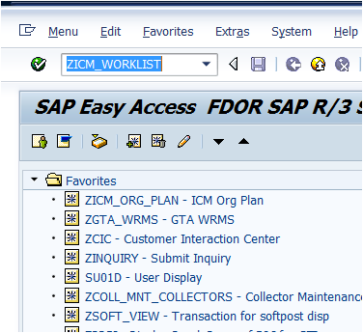

The “ICM Work List – Audit / Campaigns” screen displays.

Double-click on the row to access the lead.

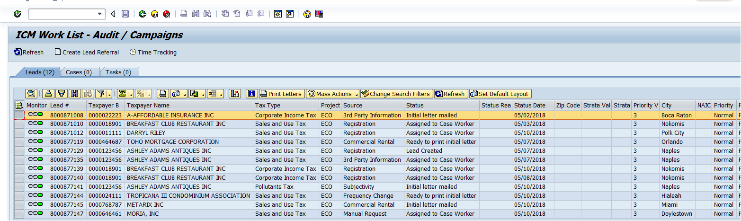

***Note: You can also use the Change Search Filters button to display the Selection Criteria screen and enter specific search criteria to display and access leads.***

**ECO Lead Screen**

The Edit: Compliance Lead screen displays.

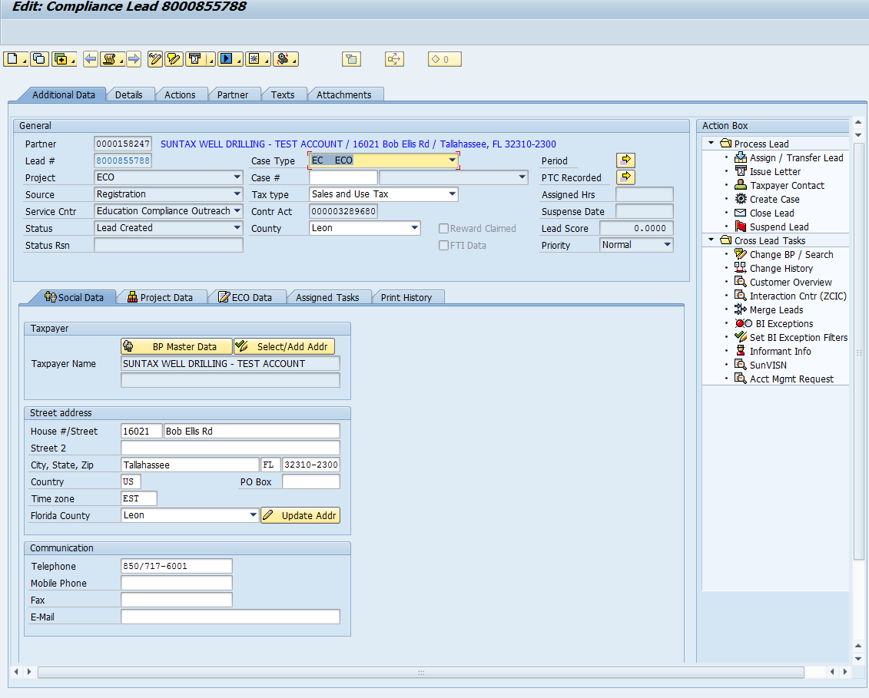

There are several tabs on this screen which the ECO Caseworker will use to view and update information. The following provides an overview of the key tabs you will use.

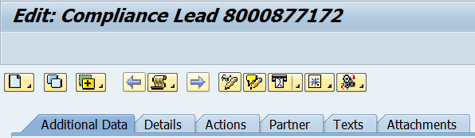

***Note: These tabs are located at the top of the lead screen.***

The information you will find on these tabs include:

**Additional Data** – General information such as Project, Source, Case Type

**Details** – Update Status and enter Notes regarding the ECO Lead

**Actions** - Not in use for ECO

**Partner** - Lists the partners on this lead

**Texts** - Notes summary, Lead notes, and Taxpayer Contact notes

**Attachments** - Allows the user to attach files relating to the lead



***Note: These tabs are located on the lower section of the lead screen.***

**Social Data** - Name, Address, and Contact numbers

**Project Data** - Registration Created on Date, NAICS, SIC, Kind Code

**ECO Data** – Update ECO Details and Case Data

* Letter Mailed
* Not Mailed
* No Response
* Outgoing Calls
* Incoming Calls
* SCORE Referral
* Correction Made
* Speaking Engagement
* Assistance Needed
* No Assistance Needed
* Office Visit
* Field Visit
* Collection Amount
* Correction Amount
* Physical SC - User’s physical service center. This section needs to be selected when correspondence is printed.
* Primary NAICS - Drop down will be available if the case has a NAICS code
* Changed By - User ID of the User that last changed the lead
* Changed At - Time the User made the change
* Changed On - Date the change was made

**Assigned Tasks** – Caseworker can assign a task to themselves or another caseworker for actions needed on the lead

**Print History** - Shows a history of letters printed for the lead